به نام خداوند جان و خرد


معاونت پژوهش و فناوری
دانشکده ؟؟؟؟- گروه ؟؟؟؟
گزارش طرح پژوهشی

عنوان طرح نوشته شود (بی تیتر 14 بولد؛ تایمز 14 بولد، نامهای علمی ایتالیک)

مجری طرح:
احمد احمدی

همکاران طرح:
محمد محمدی
حسین حسینی

تابستان 1403

شناسنامه طرح
معاونت پژوهش و فناوری
دانشکده ؟؟؟؟- گروه ؟؟؟؟

1- عنوان: عنوان نوشته شود (بی زر 12؛ تایمز 10)
2- مجری طرح: احمد احمدی
3- همکاران طرح: محمد محمدی و حسین حسینی
4- ناظر طرح: جواد جوادی
5- اعتبار طرح: 187/053/19 ریال
6- محل تامین اعتبار: از محل اعتبارات پژوهشی دانشگاه علوم کشاورزی و منابع طبیعی گرگان
7- تصویب: پیشنهادیه طرح در جلسه ؟؟؟ مورخ ؟؟/؟؟/؟؟14 شورای پژوهشی و فناوری دانشگاه به تصویب رسید.
8- اختتام: گزارش نهایی طرح در جلسه ..............مورخ .............. شورای پژوهش و فناوری دانشگاه به تصویب رسید.
9- شماره شناسه طرح: 69-456-00

مسئولیت صحت مطالب مندرج در این گزارش بر عهده مجری طرح می‏باشد.

چکیده
چکیده نوشته شود (بی لوتوس یا بی زر 12؛ تایمز 10؛ نامهای علمی ایتالیک شوند)

واژههای کلیدی: ؟؟؟؟، ؟؟؟؟؟، ؟؟؟؟؟، ؟؟؟؟؟؟؟ (بی لوتوس یا بی زر 11).

چکیده این گزارش در سایت معاونت پژوهش و فناوری دانشگاه در آدرس www.gau.ac.ir قابل دسترس می‏باشد.

Contents
Title Page
Chapter one: Introduction
1.1. Title ........................................................................................................ 1
1.1.1. Subtitle ................................................................................................ 1
1.1.1.1. Sub-subtitle ...................................................................................... 3
1.2. Title ........................................................................................................ 5
1.3. Title ........................................................................................................ 7
1.3.1. Subtitle ................................................................................................ 9
1.4. Hypotheses ........................................................................................... 12
1.5. Purposes ............................................................................................... 15
Chapter two: Materials and Methods
2.1. The selection of plants ......................................................................... 18
2.2. Sources of information ........................................................................ 20
2.2.1. GISS methodology ............................................................................ 20
2.2.1.1. Sub-subtitle .................................................................................... 21
2.2.1.2. Sub-subtitle .................................................................................... 22
2.3. Statistical analyses ............................................................................... 23
Chapter three: Results and Discussion
3.1. Status, life form and origin of alien plant species ............................... 25
3.2. GISS impact assessment ...................................................................... 27
3.2.1. Distribution of alien plant species .................................................... 29
3.3. Management of alien plant species ...................................................... 32
3.4. Discussion ............................................................................................ 33
3.5. Conclusions .......................................................................................... 39
References .................................................................................................. 43

List of Tables
Title Page
Table 1. list of 52 alien plants in Iran and their main characteristics ......... 25
Table 2. Common management methods for alien plants .......................... 28

List of Figures
Title Page
Figure 1. Alien plants categorized as invasive, perennial and annual alien plants ........................................................................................................... 32
Figure 2. Number of alien plant species according their invasive status in different habitats in Iran .............................................................................. 40
Figure 3. The distribution of 52 alien plants in Iran and their invasion status with mean GISS score (min-max) for each ecological zone ...................... 45

Chapter one: Introduction

1.1. Title
In the last decade, there has been increased evidence about the negative impacts of alien species on the environment, the economy and human well-being in all parts of the world (Vilà et al., 2011; Rumlerová et al., 2016; Nentwig et al., 2018). Providing data about the current status and distribution of problematic alien plants is essential for reducing significant adverse impacts (Simberloff, 2013; Pyšek et al., 2020; Gallardo et al., 2019; Sohrabi et al., 2020).

1.1.1. Subtitle
In the last decade, there has been increased evidence about the negative impacts of alien species on the environment, the economy and human well-being in all parts of the world (Vilà et al., 2011; Rumlerová et al., 2016; Nentwig et al., 2018). Providing data about the current status and distribution of problematic alien plants is essential for reducing significant adverse impacts (Simberloff, 2013; Pyšek et al., 2020; Gallardo et al., 2019; Sohrabi et al., 2020).

1.1.1.1. Sub-subtitle
In the last decade, there has been increased evidence about the negative impacts of alien species on the environment, the economy and human well-being in all parts of the world (Vilà et al., 2011; Rumlerová et al., 2016; Nentwig et al., 2018). Providing data about the current status and distribution of problematic alien plants is essential for reducing significant adverse impacts (Simberloff, 2013; Pyšek et al., 2020; Gallardo et al., 2019; Sohrabi et al., 2020).

1.2. Hypotheses
1.
2.
3.

1.3. Purposes
1.
2.
3.

Chapter two: Materials and Methods

2.1. Title
In the last decade, there has been increased evidence about the negative impacts of alien species on the environment, the economy and human well-being in all parts of the world (Vilà et al., 2011; Rumlerová et al., 2016; Nentwig et al., 2018). Providing data about the current status and distribution of problematic alien plants is essential for reducing significant adverse impacts (Simberloff, 2013; Pyšek et al., 2020; Gallardo et al., 2019; Sohrabi et al., 2020).

2.1.1. Subtitle
In the last decade, there has been increased evidence about the negative impacts of alien species on the environment, the economy and human well-being in all parts of the world (Vilà et al., 2011; Rumlerová et al., 2016; Nentwig et al., 2018). Providing data about the current status and distribution of problematic alien plants is essential for reducing significant adverse impacts (Simberloff, 2013; Pyšek et al., 2020; Gallardo et al., 2019; Sohrabi et al., 2020).

2.1.1.1. Sub-subtitle
In the last decade, there has been increased evidence about the negative impacts of alien species on the environment, the economy and human well-being in all parts of the world (Vilà et al., 2011; Rumlerová et al., 2016; Nentwig et al., 2018). Providing data about the current status and distribution of problematic alien plants is essential for reducing significant adverse impacts (Simberloff, 2013; Pyšek et al., 2020; Gallardo et al., 2019; Sohrabi et al., 2020).

2.2. Title
In the last decade, there has been increased evidence about the negative impacts of alien species on the environment, the economy and human well-being in all parts of the world (Vilà et al., 2011; Rumlerová et al., 2016; Nentwig et al., 2018). Providing data about the current status and distribution of problematic alien plants is essential for reducing significant adverse impacts (Simberloff, 2013; Pyšek et al., 2020; Gallardo et al., 2019; Sohrabi et al., 2020).

Chapter three: Results and Discussion

3.1. Title
In the last decade, there has been increased evidence about the negative impacts of alien species on the environment, the economy and human well-being in all parts of the world (Vilà et al., 2011; Rumlerová et al., 2016; Nentwig et al., 2018). Providing data about the current status and distribution of problematic alien plants is essential for reducing significant adverse impacts (Simberloff, 2013; Pyšek et al., 2020; Gallardo et al., 2019; Sohrabi et al., 2020).

3.1.1. Subtitle
In the last decade, there has been increased evidence about the negative impacts of alien species on the environment, the economy and human well-being in all parts of the world (Vilà et al., 2011; Rumlerová et al., 2016; Nentwig et al., 2018). Providing data about the current status and distribution of problematic alien plants is essential for reducing significant adverse impacts (Simberloff, 2013; Pyšek et al., 2020; Gallardo et al., 2019; Sohrabi et al., 2020).

3.1.1.1. Sub-subtitle
In the last decade, there has been increased evidence about the negative impacts of alien species on the environment, the economy and human well-being in all parts of the world (Vilà et al., 2011; Rumlerová et al., 2016; Nentwig et al., 2018). Providing data about the current status and distribution of problematic alien plants is essential for reducing significant adverse impacts (Simberloff, 2013; Pyšek et al., 2020; Gallardo et al., 2019; Sohrabi et al., 2020).

3.2. Title
In the last decade, there has been increased evidence about the negative impacts of alien species on the environment, the economy and human well-being in all parts of the world (Vilà et al., 2011; Rumlerová et al., 2016; Nentwig et al., 2018). Providing data about the current status and distribution of problematic alien plants is essential for reducing significant adverse impacts (Simberloff, 2013; Pyšek et al., 2020; Gallardo et al., 2019; Sohrabi et al., 2020).

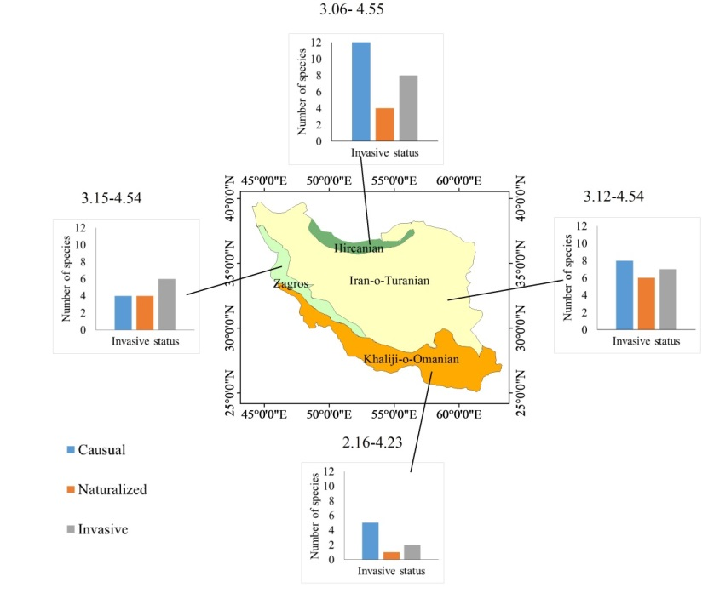
Figure 1. The distribution of 52 alien plants in Iran and their invasion status. The numbers above each graph are mean GISS score (min-max) for each ecological zone (Original).

Table 1. Common management methods for alien plants, * indicate alien plants with high impact score (> 4) and species that receive management in Iran are highlighted in bold.
Plant species | Chemical control | Other Control Methods (mechanical or physical and cultural control) | management recommendations | References
Eichhornia crassipes* | Bispyribac sodium | Cutting and collecting | Combination of biological and physical control | Yaghoubi et al. 2020; Karouach et al. 2022
Ailanthus altissima * | Systemic herbicide injection | Cutting | Stem injection | Brundu 2017
Eupatorium cannabinum | Systemic herbicdes | Manual removal | Manual removal | http://www.iucngisd.org
Imperata cylindrica * | Glyphosate | Moving | Combination of chemical and physical control | Zand et al. 2017; Eskandari, et al. 2020
Pueraria montana var. lobata * | Systemic herbicdes | Cutting and collecting | Thermal treatment | http://www.iucngisd.org
Amsinckia menziesii * | 2,4-D and MCPA | Hand weeding | Chemical control | Sajedi et al. 2012; Zand et al. 2017

3.3. Conclusions
In Iran there are more than 20 alien plant species with high impact based on GISS. The highest environmental and socioeconomic impacts are reported for perennial alien plants like Eichhornia crassipes, Imperata cylindrica and Cynanchum acutum that invade wetlands and agricultural lands. Ailanthus altissima, Pueraria montana var. lobata and Fallopia japonica occur in urban areas and forests. Applying more restrictions to importing new plants specifically in the Hircanian zone is essential. Hircanian forests, which are known as the wet or Caspian forests, have high environmental and economic values. These forests are a World National Heritage site (https://whc.unesco.org) and should also be considered a potential hotspot for biological invasion in Iran.

Acknowledgements: Gorgan University of Agricultural Sciences and Natural Resources (GUASNR), Iran supported this research (project No: 94-666-20).

References

Abstract
Times New Roman 12. The greenbug, Schizaphis graminum (Rondani), is one of the major pests of wheat worldwide. Due to the environmental and health consequences of pesticide, the use of "induced resistance" as a biorational method in integrated pest management has been greatly developed in recent years.

Keywords: Schizaphis graminum, Wheat, Induced resistance, Times New Roman 11.

Gorgan University of Agricultural
Sciences and Natural Resources

Vice Presidency for Research and Technology
Faculty of ????-Department of ????

Research Report

Induced resistance of three varieties of wheat (Triticum aestivum L.) against the greenbug aphid, Schizaphis graminum Rondai (Hem.: Aphididae)

By:
Ahmad ahmadi

Co-Workers:
Mohammad Mohammadi
Hossein Hosseini

Summer 2024

. Negative impacts
. Alien species

